Var arg method :

It stands for variable arguments method.

In java, if we have variable no of arguments , then compulsorily new method has to be written till jdk 1.4

But in jdk 1.5 , we can write single method which can handle variable no of arguments ( but all of them should be of same type )

Syntax : methodOne(datatype… variableName)

…=> It stands for ellipse ( … compiler understands it is variable arguments)

Eg: Var_Args_Eg1

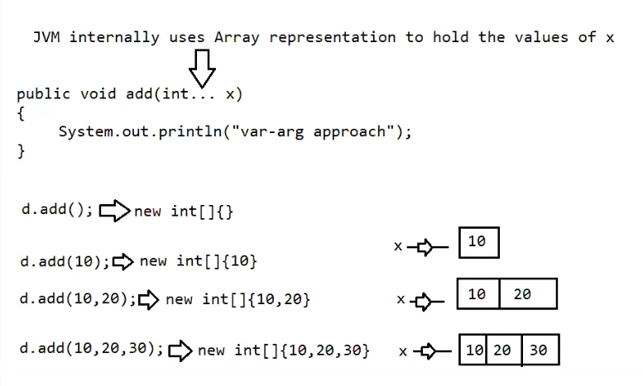

Note: internally var-arg method will be converted to single dimensional array, so we can access var arg method arguments using index.

Eg: Var_Args_Eg2

Eg: Var_Args_Eg3

Case1: valid signatures

1. public void methodOne(int… x)
2. public void methodOne(int…x)
3. public void methodOne(int …x)

Case2 :

We can mix normal argument with var argument

public void methodOne(int x , int… x)

public void methodOne(String s , int… x)

Case3 :

While mixing var argument with normal argument var argument should always be last

public void methodOne(int… x , int y) // invalid

case 4:

In an argument list there should only be one var argument

public void methodOne(int… x , int…x ) // invalid

case 5:

we can overload var arg method , but var arg method will get call only if none of the matches are found.

( just like default statement of switch case )

Eg: Var_Arg_Overload

Case 6:

public void methodOne( int… x ) => internally it is be replace by int[] x , so it can be replaced by int[] x

Eg: Internal_replacement_In_Var_Args

Case 7 :

public void methodOne(int… x )

public void methodOne(int[] x)

// we cant have 2 methods with same signature , it leads to compile time error .

Eg: Var_Arg_Method_Signature

single dimensional array vs var arg method :

1. wherever single dimensional array is present we can replace it with var args

Eg: public static void main (String[] args ) => String… args

1. wherever var arg is present we cannot replace it with single dimensional array

Eg: public void methodOne (String… args ) => String[] args // invalid

// only in some cases are valid we can do the second case in main method , but it is not possible in normal method containing var args .

Note:

m1(int… x) => we can make a call to this method by passing group of int values ( as parameters ) and x will become 1d array (int[] x) .

m1(int[] x) => we can call this method by passing 1d array only

Note :

Eg: One_Dimensional_Array_Var_Args

Eg: Two_Dimensional_Array_Var_Args

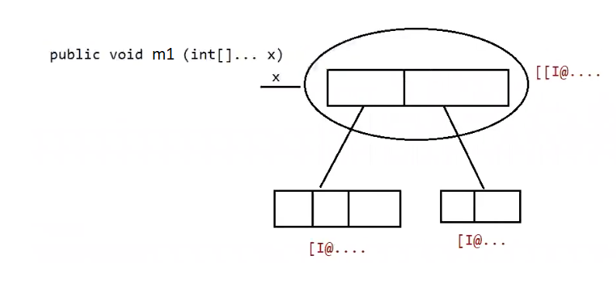

m1(int…x)

=>we can call this method by passing group of int values , so it becomes 1-D Array

m 1(int[]… x)

* we can call this method by passing group of 1D int[] , so it becomes 2-D Array

Wrapper class:

1. Autoboxing
2. Widening ( implicit type casting done by compiler ( applicable for both primitive and wrapper)
3. Var - Args

Case1 :

Widening vs autoboxing

Eg: Widening_Vs_AutoBoxing_Eg1

Primitive ====🡺 do type casting ==🡺 found ===🡺 long ( binding happens by compiler)

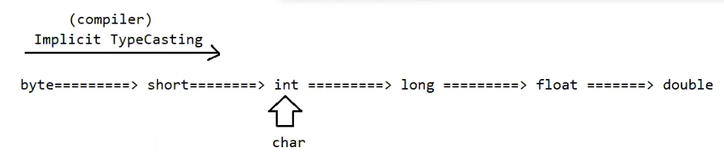

Eg: Widening_Vs_Var_Args

Primitive ====🡺 do type casting ==🡺 found ===🡺 long ( binding happens by compiler)

Eg: AutoBoxing_Vs_Var_Args

// go through the code

Eg: AutoBoxing_Vs_UnBoxing

Note : widening followed by autoboxing is not allowed in java , but autoboxing followed by widening / typecasting is allowed. If it is not overloaded methods

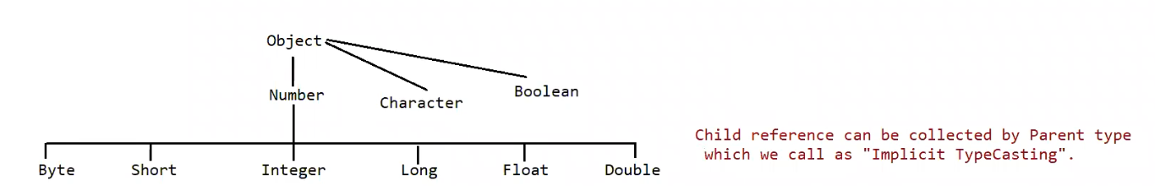

Eg: Conversion_AutoBoxing

// o/p : Number , since it is the first immediate parent.

Which of the following declarations are valid ?

1. int i=10;//valid

2. Integer I=10; //AutoBoxing(valueof())

3. int i=10L; // invalid(long===> int)

4. Long I = 10L; //AutoBoxing(valueOf())

5. Long I = 10; //AutoBoxing=> Integer====> Number, Object, so invalid

6. long I = 10; // valid(int===> long)

7. Object o=10; //AutoBoxing==> Integer ===> Number, Object so valid

8. double d=10; // valid(int===> double)

9. Double d=10; // AutoBoxing=> Integer====> Number, Object, so invalid

10. Number n=10; //AutoBoxing==> Integer ===> Number, Object so valid

Note :

In general var-arg method will get the least priority , i.e if no other method is matched only then var-arg method will get a chance .

It is exactly same as default inside switch

While resolving the overloaded methods the compiler will give the precedence in the following order.

1. Widening
2. AutoBoxing

Type casting is possible only when two classes have parent child relationship.

Eg: Var_Args_Eg4

Here variable argument in method go is the first argument , so it throws compile time error . variable argument should be the last one.

Eg: Var_Args_With_Respect_To_Main_Method

// go through the code

Eg: Var_Args_Eg5

// compiler will search for the exact match of a method that accepts two int arguments, it if it is found that method is loaded.

Variable arguments is always given the least priority.